Monday, 7 September 2026, postcard

More portraits (and The Portrait), the Original Ivy, and Avenue Q.

It's aliiiiive! David emerged, as planned, at 8:45 am, and we went off to a pub in the square called The Moon Under Water for breakfast. It's only one of 827 pubs (by actual count) in the UK (some with hotels attached) run by the Wetherspoon company, 47 of which are called The Moon Under Water. Ours is the Moon Under Water Westminster. The name is a quote from George Orwell, who used it in a description of his (imaginary) ideal pub.

The food was good, and the prices excellent. You could order in person at the bar, but I decided to try the "scan this QR code to order" option, which worked perfectly. From the extensive menu, David ordered the eggs benedict, and I chose the "small traditional breakfast": a fried egg, (English style) bacon, a Lincolnshire sausage, baked beans, and a hashbrown cake, to which I added the optional black pudding slice. We both had tea (they had PG Tips!). All for half the price of the Indigo's so-so continental buffet. I can't believe I didn't take pictures, but I'll get some when we go back for breakfast tomorrow.

Construction continues on the preparations for the movie premier, which keeps expanding its fenced footprint—a bazillion lights, scaffolding, tons of other equipment. According to Google, the next premier scheduled for this venue is Sense and Sensibility on 15 September. Do they really plan to keep constructing more and more for another whole week?! Aside from Fiona Shaw, I don't recognize any of the cast.

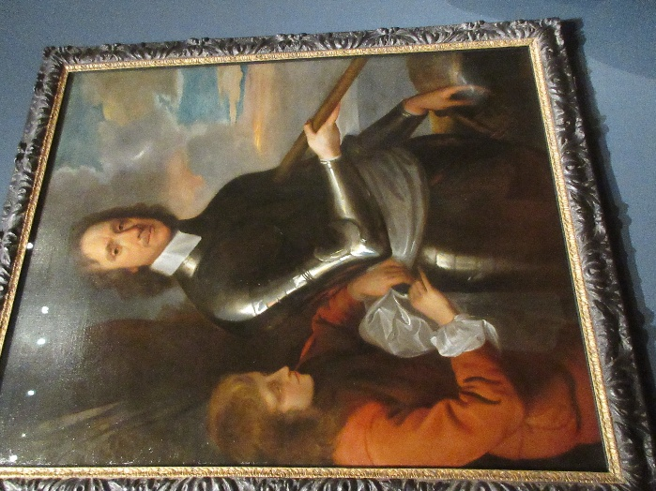
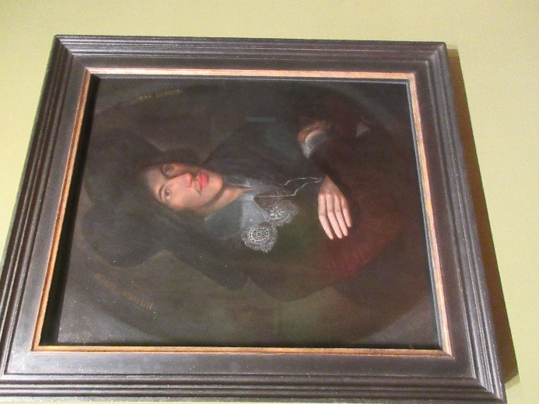
After breakfast, we went back to the NPG, where we found we hadn't covered as much of the third floor as we thought—we still didn't finish it. They've got pictures of everybody in there. Here, at the left, is John Donne (artist unknown) and at the right, Oliver Cromwell (by Robert Walker). I took scores of photos and will include more of them (though by no means all) in the full travel diary, when I get around to writing that up.

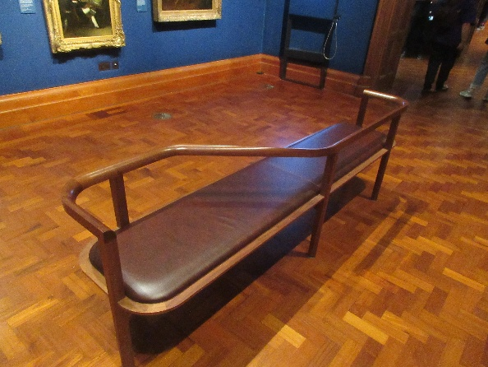
We found that the portable stools were less useful to sit on than in most galleries, because portraits lend themselves less to sitting and staring than other genres. One of the best features of this gallery is the amount of information given on the labels about the subjects, as opposed to the artists, and if you sat far enough from the portrait to view it, you were too far away to read the label. Still, I found my feet held up much longer with the folded stool to lean on, like a cane. In addition, the gallery provided these beautifully designed benches in many of the rooms. They varied in length and in percentage of the length facing one way or the other.

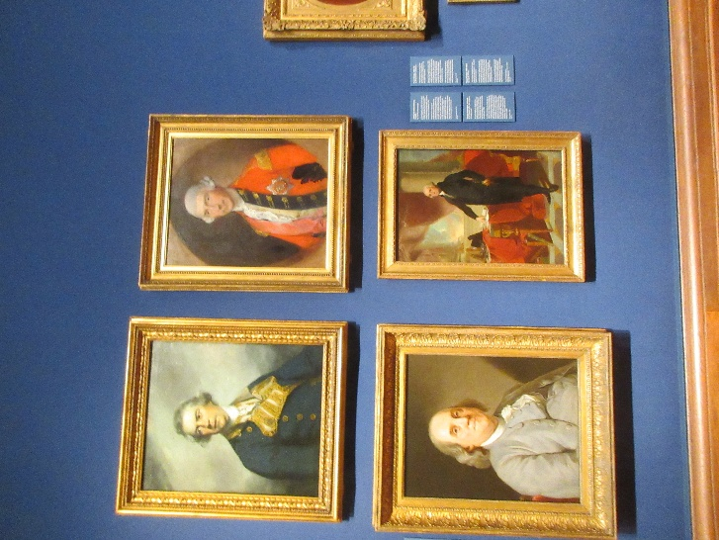
Here's one more image, a four-fer, as it were. On the left are Augustus, Viscount Keppel (by Joshua Reynolds) and Ben Franklin (artist unknown, after a portrait by Joseph Duplessis); on the right Jeffery, 1st Baron Amherst (by Thomas Gainesborough), and George Washington (artist unknown, after a portrait by Gilbert Stuart). That's the Lord Jeffery Amherst for whom the Massachusetts town and college are named, and as everyone knows who went to Amherst (or has a brother-in-law who did), the NPG misspelled his name. It's Jeffery, not "Jeffrey" as their label shows. As his namesake, my nephew Jeff, says, "It's R before E except when it's me."

At noon, we presented ourselves at The Portrait, the gallery's high-end restaurant, just at opening time and were able to get in easily despite dire warnings that reservations were prudent. It's on the top floor, and the view over the city was great.

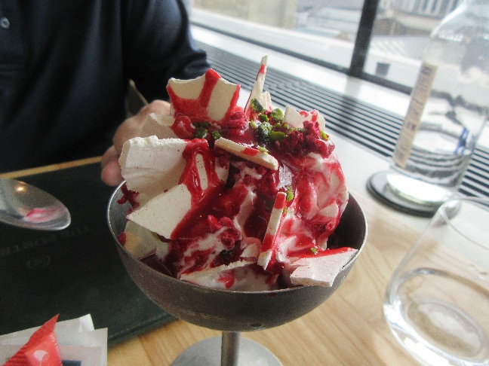
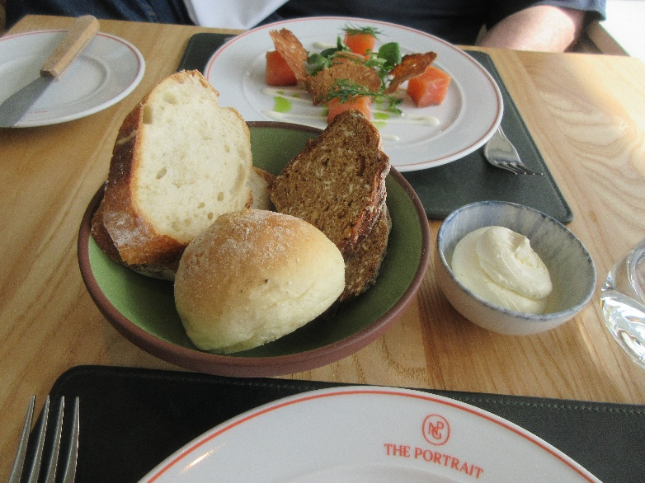
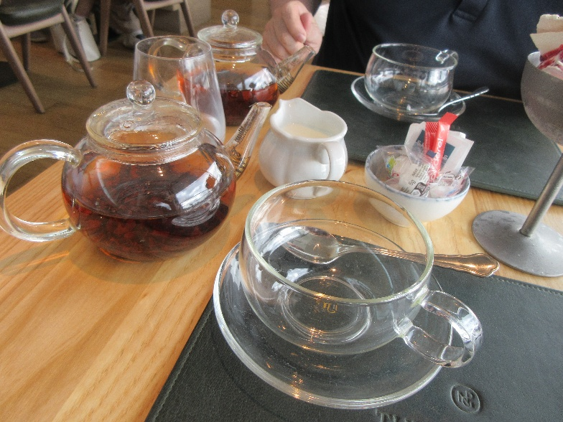
We shared the basket of artisan bread (and butter), each ordered the smoked salmon first course, then split the restaurant's version of a Knickerbocker glory for dessert. The latter was a big scoop of (superb) vanilla ice cream topped with raspberry coulis, whipped cream, pieces of freeze-dried raspberries, shards of crisp meringue, more raspberry coulis, and a sprinkle of pistachios. Outstanding! We each ordered tea with that and got outstanding Assam English Breakfast in this lovely glass service. Note the large-leaf loose tea and the clever spring-coil strainer to keep the leaves in the pot.

Then back to the hotel, where David could indulge in his favorite vacation activity—napping—while I wrote.

Tonight's show is Avenue Q, which we've seen before. (Where was that? New York? Washington? London?) But it was great and bears repeating.

Accordingly, I reserved at The Original Ivy, a restaurant near the midpoint of our 11-minute walk to the Shaftesbury Theatre.

I started with French onion soup—very rich, beefy flavor, but the onions were strangely chewy. David had the ragout of wild mushrooms on pappardelle pasta.

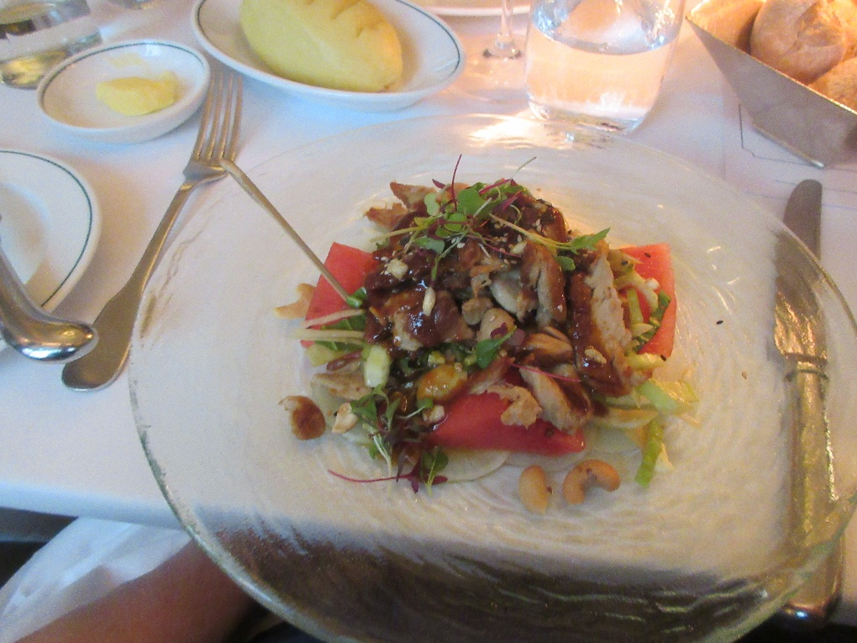
Then he had roast venison with beets, parsnip purée, and crispy fried parsnip ribbons, and I had the crispy duck salad with cashews, ginger, watermelon, sesame, and hoisin. Scrumptious. No time for dessert.

Avenue Q is 20 years old this year, and it is still a riot.

